Structure Chart :

Stamp dispenser

Calculate coins

Stamp dispense

Input

Available

Output

value

balance

same denomination of coins

Output :

* Invalid input (coin)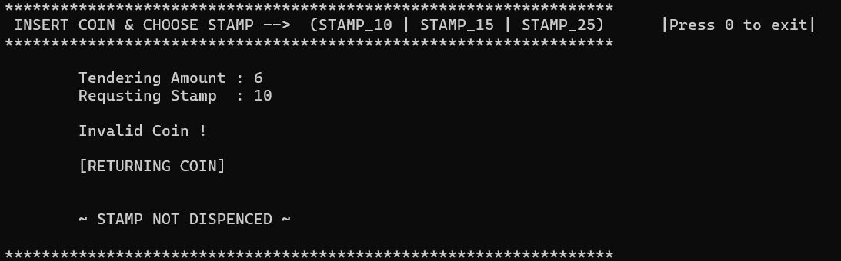
* Invalid input (stamp)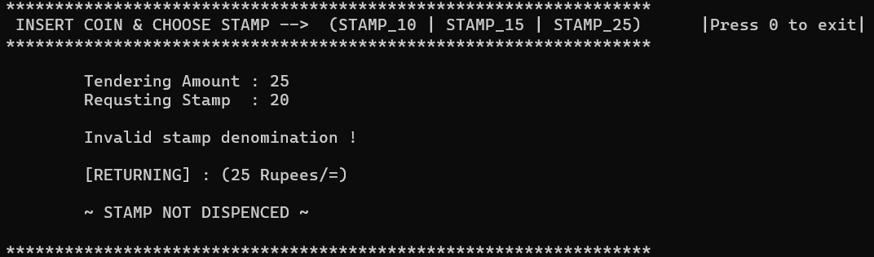
* Dispense stamp with change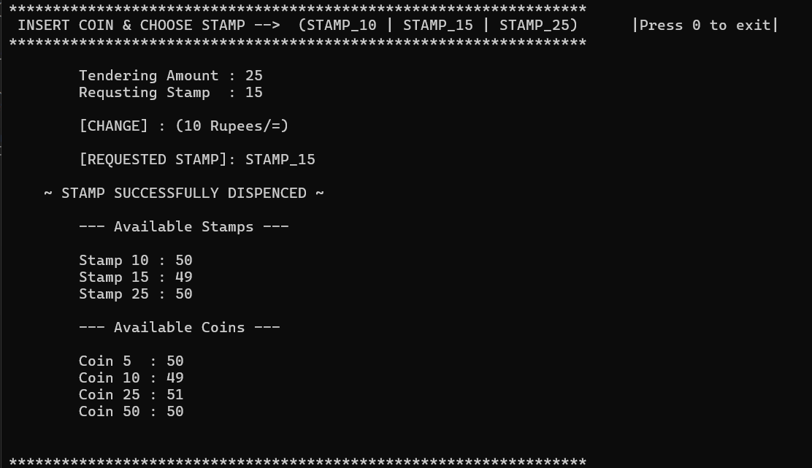

Then, (It shows available coins at the end)

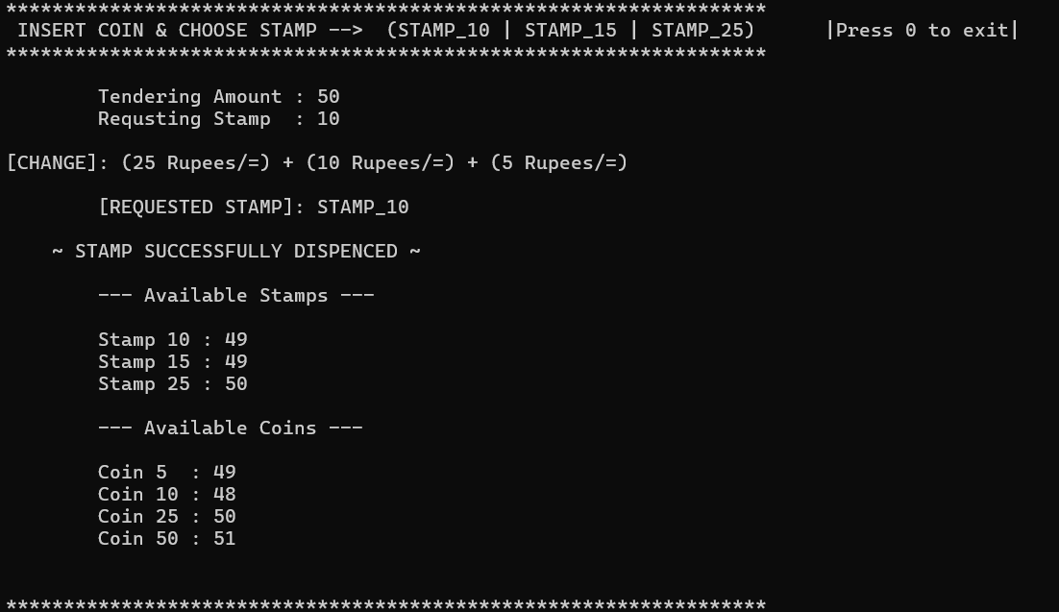

* Same stamp for same coin

(no change available)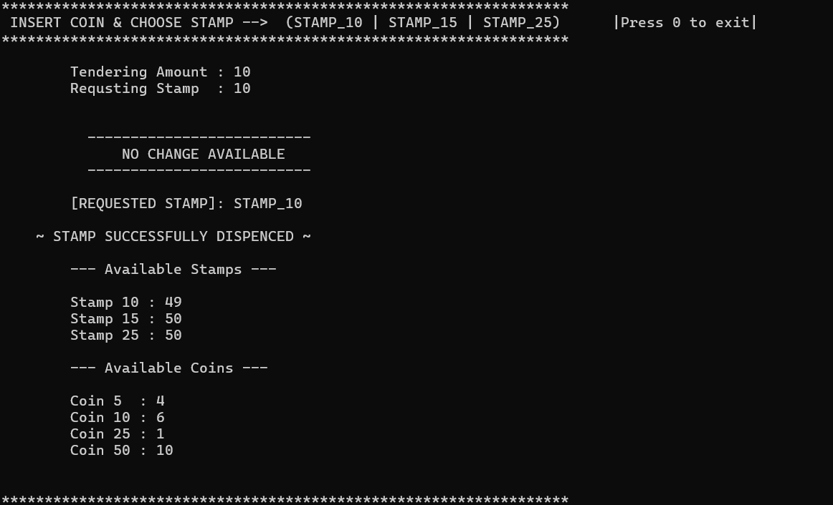

* Insufficient amount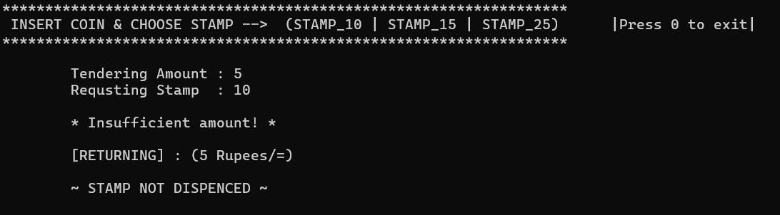
* Same denomination for return coins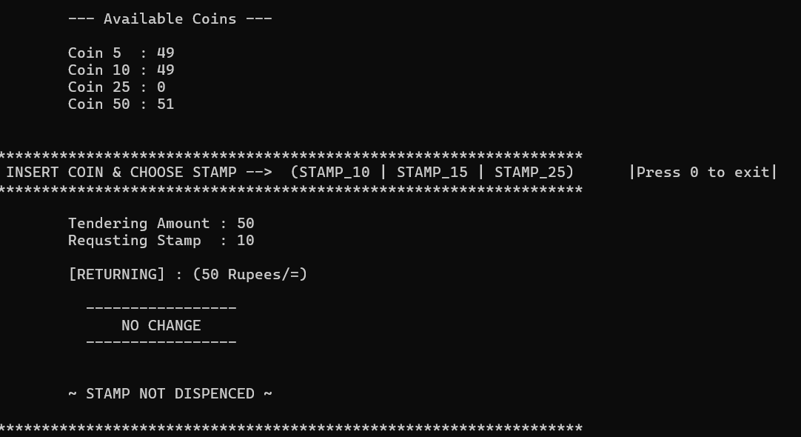

Another example,

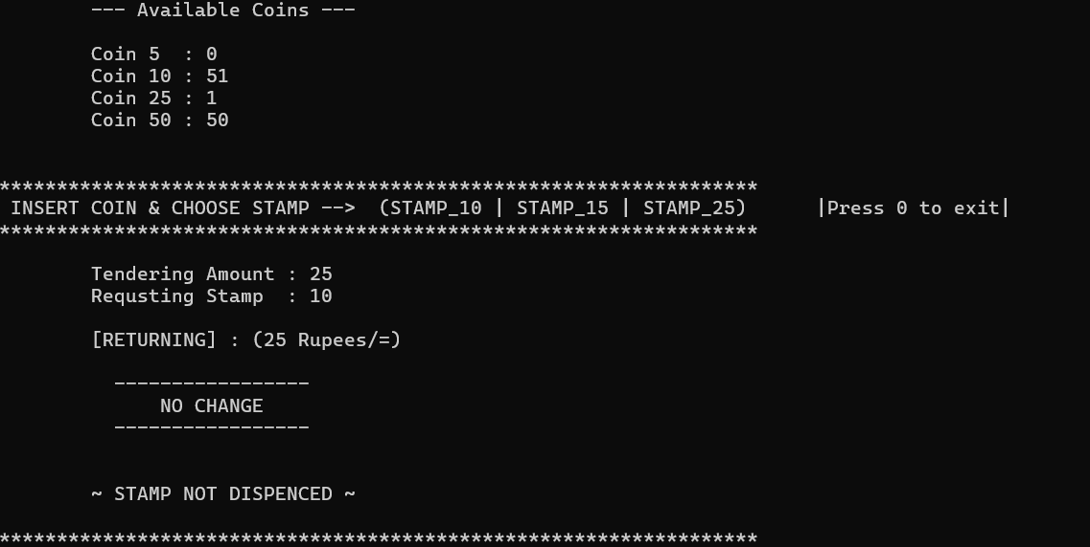

* Out of stamps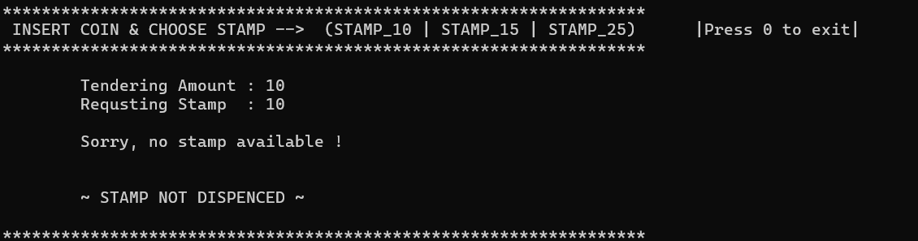
* Exit the program